Module Two Milestone

Curtis Thomas

SNHU CS-330

Module Two Milestone

In this project, a 2D image will be selected to be recreated in 3D. Four objects to represent in 3D using primitives will be selected from the given image, at least one of which will be comprised of two or more primitives. With each chosen object, the author will defend his choice for including it in the project. Lastly, the author will explain how each of the objects will be represented using 3D primitives.

# Selecting an Image

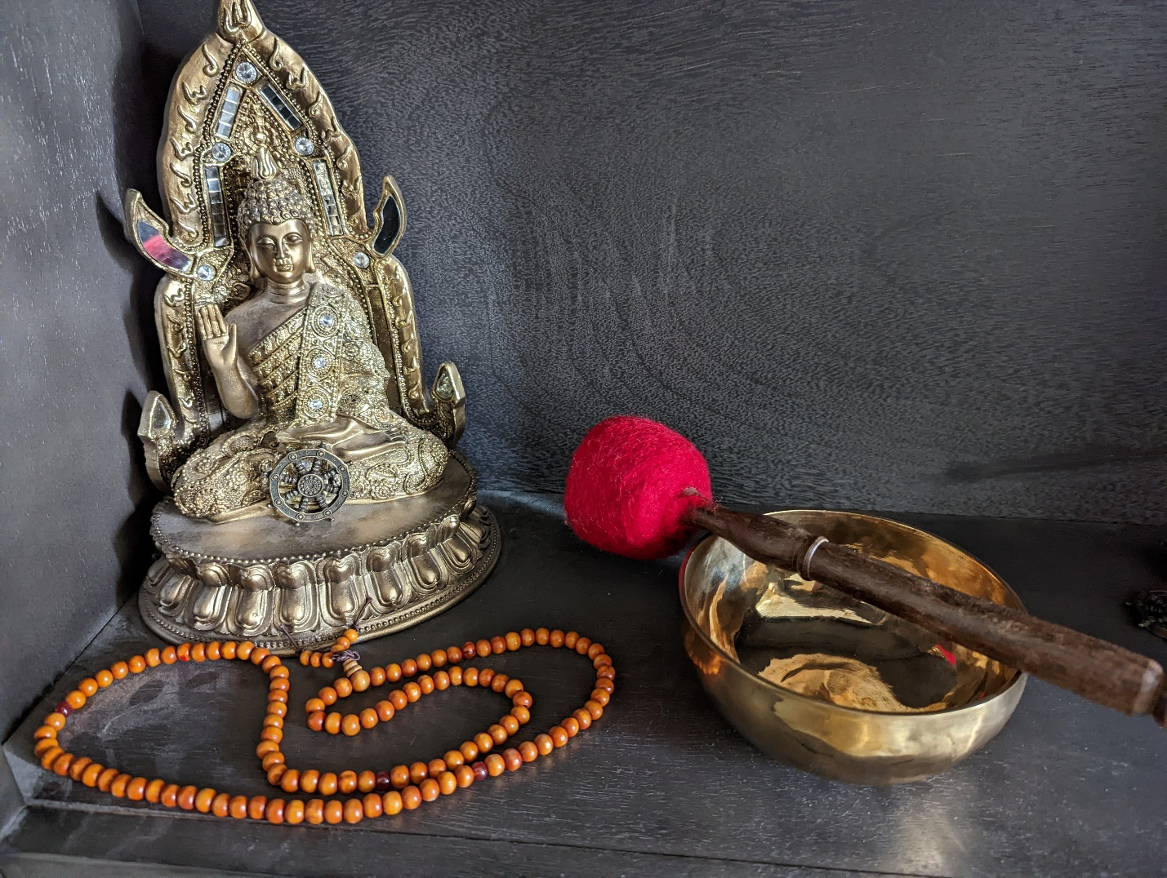

Figure : Curtis Thomas' home shrine

For this week’s work, the author selected an image of his home’s shrine to the Buddha. It includes the Buddha statue, a string of Mala beads (sometimes called prayer beads), a singing bowl, a mallet for the singing bowl, the shelf on which the Buddha rests, and a Dharma Wheel (the object which looks like a ship’s wheel sitting directly in front of the Buddha). This image was chosen because it is a simple, personal scene with objects that can be reliably represented with primitives.

## Choosing the objects

The assignment demands that the objects selected be represented by the following primitives (or combinations thereof): cube, cylinder, plane, pyramid, sphere, and torus. For the purpose of this assignment, the author assumed that a plane on which the objects rest is not included in the demand for four objects. The first of the four objects chosen will therefor include the Buddha, who seems very complex at first glance but could be roughly represented with the combination of multiple primitives. The second of the four objects is the Mala beads, which provides an opportunity for complexity or simplicity, depending on the needs of the project. The third object is the mallet, which is a relatively simple device to represent with the combination of two primitives. The fourth object is the singing bowl, which should be straightforward to represent in 3D. Taken together, these four objects should clearly communicate to the viewer that they are looking at a Buddhist shrine.

### Representing the objects.

Representing the Buddha will employ the use of a cube for the head, cube for the body, pyramid for the top-knot, cube (as a rectangle) for the hand and arm, and cube for legs; the Buddha’s platform could also be represented as a cube. Representing the Mala beads could be done by laying a number of spheres in series, however they could also be effectively represented by the use of a torus to show the circuitous profile of the beads should the spheres prove too complex. Representing the mallet could be done with the use of two cylinders: a thinner, longer one for the handle, and shorter, thicker one for the head. Representing the singing bowl could be reasonably accomplished with the use of a cylinder with its top face removed or else half of a sphere.

References

Thomas, Curtis R. (9 March 2022). *Photograph of personal shrine* [Digital Photograph]